Date: October 20, 2023

BOARD INFORMATION: __X__

MEETING PREPARATION: _____

FROM: Carmen Sanders, Executive Director of Instructional Support
Julia Neufer, STEM Coordinator and Elementary Math Instructional Specialist
Suzanne Futrell, Secondary Math Instructional Specialist

THROUGH: Dr. Pierrette Finney, Ed.D., Chief Academic Officer
Melanie Kay-Wyatt, Ed.D., Superintendent of Schools

TO: The Honorable Michelle Rief, Chair, and
Members of the Alexandria City School Board

TOPIC: Additional Mathematics Course Option, Pre-Algebra

ACPS 2025 STRATEGIC PLAN GOAL:
Goal 1: Systemic Alignment
Goal 2: Instructional Excellence

SY 2023-2024 PRIORITY AREA:
Academic Achievement
Tier 1 Instruction: Alignment, Rigor, Engagement

FY 2024 BUDGET PRIORITY:

SUMMARY:
The 2023 Mathematics Standards of Learning were approved by the Virginia Board of Education on August 31, 2023. The foundation of the new standards are rooted in the Virginia Math Process Goals. The 2023 Mathematics Standards of Learning represent "best in class" standards and comprise the mathematics content that teachers in Virginia are expected to teach and students are expected to learn. Along with an increased focus on rigor and depth, math concepts were added, deleted, and moved from grade levels and courses in the new standards. Some courses such as Algebra 1 had significant changes to the course content. In order to support the successful implementation of the standards and student readiness for Algebra I and Geometry, ACPS is offering an additional course option of Pre-algebra after students complete Math 7 or Math 7 Honors.

DETAILS:
The addition of a Pre-Algebra option at the middle school level provides an additional opportunity for students and ensures more students are successful in high school level math courses. The addition of the course does not impact the ability of students to take Algebra I in middle school. Students will receive a recommended math placement of Algebra I or Pre-Algebra after the completion of Math 7 or Math 7 Honors. Placement recommendations are determined by a team of educators using multiple data points. Parents/Guardians are notified of their student’s recommended math placement. Students may still enroll in Algebra I after the completion of Math 7 without meeting the recommended criteria, however, following this guidance is highly suggested. Parents/Guardians should discuss their preferences with members of the school staff, especially with their child's counselor. The purpose of soliciting this feedback is to increase the likelihood of student success and inform parents of the academic rigor and requirements of the Algebra I course. If a parent/guardian decides to enroll a student in a course that was not initially recommended for the student, they should notify the school staff of this decision before the end of the school year or as soon as possible after they receive notice of the recommended placement.

Current Math Course Progression
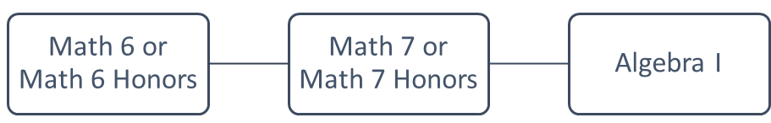

Revised Math Course Progression
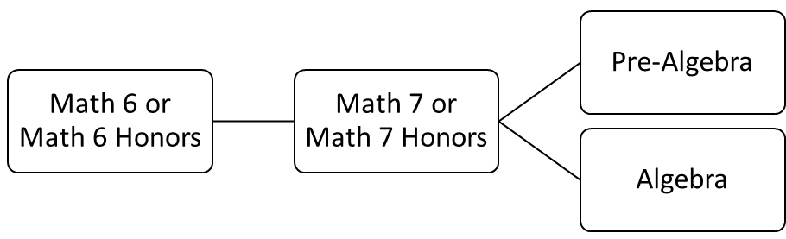
BACKGROUND:
Currently, all students in ACPS take Algebra I after taking Math 7 or Math 7 Honors. The new 2023 VDOE Mathematics Standards of Learning have added additional content such as exponential functions to the Algebra I curriculum. The additional content combined with the increased rigor of the standards have created a need for an additional option, Pre-Algebra, to prepare students for success in high school math. The Pre-Algebra course will cover the Math 8 standards of learning which are essential for success in Algebra I and Geometry.

RECOMMENDATION: The Superintendent recommends that the School Board review the updated 2023 Math 8 and Algebra I Standards of Learning and ACPS course progression options.

IMPACT:
The addition of a Pre-Algebra course option will prepare more students for success in high school mathematics courses.

REFERENCES:
N/A

ATTACHMENTS:
N/A

CONTACT:
Julia Neufer, julia.neufer@acps.k12.va.us
Suzanne Futrell, amy.futrell@acps.k12.va.us

